PSYCHIATRIC RESIDENTIAL TREATMENT FACILITY (PRTF) SUMMARY

Act 596 of 1987 called for all specialized psychiatric facilities to have a POA and license. At that time there were 226 existing PRTF beds that were “grand-fathered” into the system. The Need Methodology for PRTFs was established in 1995. According to this methodology, Arkansas projects 1.001 beds per 1,000 persons between 6-17 years old and 0.78 beds for 1,000 persons between the ages of 18-21. As of February 1, 2008, there is a moratorium on the construction or addition of PRTF beds.
The Health Services Permit Agency conducts a mandatory annual PRTF Report. According to Act 1271 of 2005 the Health Services Permit Agency is authorized to collect utilization statistics annually from health facilities requiring a permit of approval.
Survey Results
This survey relies on the quality of the entries made by respondents, and given how few PRTFs there are in Arkansas the number of survey responses will always be few in number and the values entered will vary greatly from year to year. This survey year, conducted in 2016 for events occurring in 2015, there were only four responses of acceptable quality for analysis. These surveys always cover the events and values of the previous year. These facilities were made up of three for-profits (FP) and one nonprofit (NP). Within these eight facilities there were 380 licensed beds and 183 resident rooms reported. The average number of beds per facility was 95.0, and 2.1 beds per room.
Licensed Beds
Of the 380 licensed beds reported in 2016, the FPs accounted for 296 beds within three facilities and the single NP had 84 beds.
Average Number of Residents per Rooms
The majority of the rooms reported were utilized for one or two residents, 148 out of the 183 resident rooms reported. This year’s survey showed FPs having a larger percentage of rooms with three or more residents (27 out of 127 rooms, or 21.3%) compared to NPs (8 out of 56 rooms, or 14.3%). This year there were more reported FP rooms in general, but keep in mind only one NP facility was included in the analysis.
Figure 14. Type of Resident Room by Facility Type

Payment Methods
There were 116,370 total resident days and 618 admissions in four PRTFs. Arkansas Medicaid paid for 85,722 total resident days, or 73.7%, of those days. The Medicaid cap for PRTFs is $350 per child per day; based on this rate, the potential cost to Arkansas Medicaid is $30,002,700. The remaining 26.3% was covered by Medicaid (from a state other than Arkansas), private insurance, and “other” (as listed on the survey) forms of payment.
PRTFs and Host Counties
Arkansas is split into six PRTF regions (shown in the map below), which are serviced by the four responding PRTFs around the State. Each PRTF was in a different region: Region 1’s facility was in Washington County, Region 2’s was in Stone County, Region 3’s in Pulaski County, and Region 4’s was in Dallas County. Regions 5 and 6 are not covered in this year’s analysis.

Figure 15. PRTF Regions
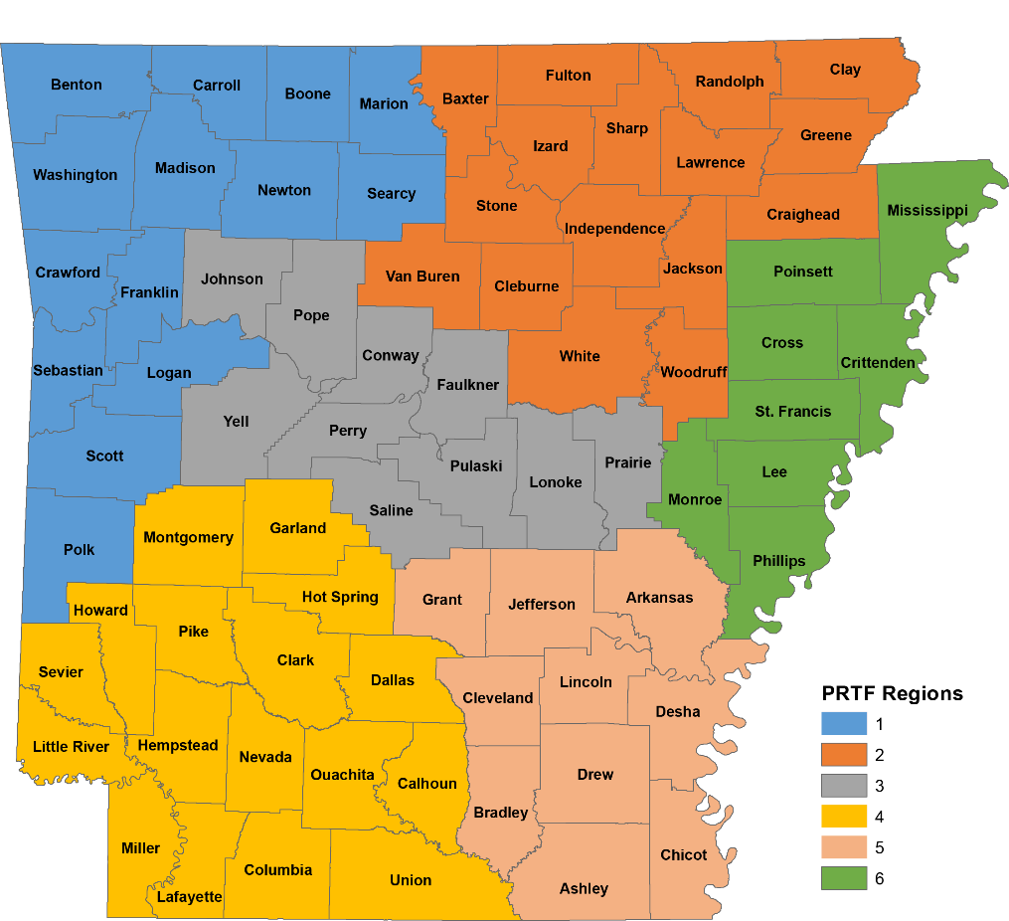

The six regions are not split evenly according to population. Regions 1 and 3 are the more populous regions in the state, and the smallest regions (5 and 6) are generally low in population (and not reported this year). Keep this in mind whenever PRTF values are compared against estimates of the population from the Census Bureau later in this report.

Occupancy Rates
The occupancy rate was calculated by taking the number of occupied beds divided by the number of licensed and available beds. The occupancy rates by region are as follows:
Region 1 – 94.1%
Region 2 – 100.0%
Region 3 – 81.0%
Region 4 – 81.8%
Region 5 – NA
Region 6 – NA
State Total –86.4%

Figure 16. Overall Percentage of Patients Served by Number of Patients Per County

Table 19. Number of Patients Served Per County
Patients Per County |  | Total Patients Seen | County
>70 pts | (1) | 84 | Pulaski
50-70 pts | (0) | 0
20-49 pts | (4) | 111 | Jefferson, Lonoke, Sebastian, Washington
11-19 pts | (10) | 139 | Ashley, Benton, Craighead, Faulkner, Garland, Miller, Ouachita, Saline, Union, White
6-10 pts | (13) | 89 | Arkansas, Baxter, Boone, Crawford, Drew, Hempstead, Hot Spring, Howard, Independence, Lincoln, Madison, Perry, Pope
1-5 pts | (39) | 117 | Bradley, Calhoun, Carroll, Chicot, Clark, Clay, Cleburne, Cleveland, Columbia, Conway, Crittenden, Cross, Dallas, Desha, Franklin, Fulton, Grant, Greene, Izard, Jackson, Johnson, Lafayette, Lawrence, Little River, Logan, Mississippi, Monroe, Nevada, Phillips, Pike, Poinsett, Polk, Prairie, Randolph, St. Francis, Sevier, Sharp, Van Buren, Yell

Gender
In 2016’s survey, there were more males than females being served in PRTFs. There were 404 boys between the ages of 6-20 and 214 girls that were 6-20 years old.
Age
The 11-15 year old range had the highest percentage of residents (57.6%), followed by 6-10 year olds (21.4%), while 21.0% of the residents were 16-18 years old, and no facility reported residents in the 19-20 year old age group.
Figure 17. Residents by Age

Figure 18. Sex and Age by Facility Type

