DRA's
Client Assistance Program (CAP)
A C C E S S T O

O P P O R T U NI T Y

Having trouble accessing services through Arkansas Rehabilitation Services (ARS)?

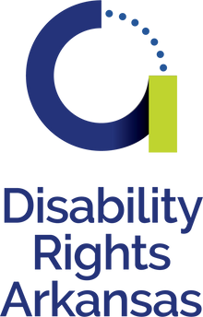
WE C A N H E L P .

C A L L T O L L - F R E E ( 800 ) 4 82 - 1 1 7 4

Space for any required legal/federal grant language

WE C A N H E L P .

NE E D
R E H A B
S E R V I C E S ?

The Client Assistance Program (CAP) is administered by Disability Rights Arkansas. If you are having trouble accessing services through Arkansas Rehabilitation Services (ARS), we have attorneys and advocates who can help at no charge to you.

We can help you access resources to help you live and work independently, including:
Assistive technology Tuition
Supported employment Assistance in developing a small business plan
Vehicle modifications And more!

We're here to help you reach your goals! Give us a call at (800) 482-1174 to learn more about how the CAP program can help you get the tools you need to succeed.

