About Us.
Disability Rights Arkansas is Arkansas’s protection and advocacy organization. We help protect the human, civil, and legal rights of people with disabilities.

Mission. Vision. Values.
Contact Us.

Main: 501-296-1775 V/TTY Toll Free: 800-482-1174 V/TTY

400 West Capitol Avenue, Suite 1200 Little Rock, AR 72201

Dignity. Respect.

Advocacy.

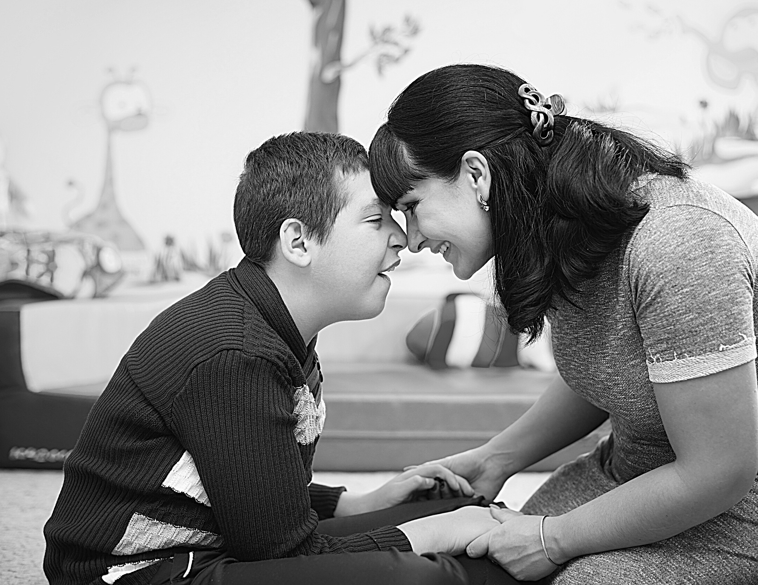
Our mission is to vigorously advocate for and enforce the legal rights of people with disabilities.

We envision an Arkansas where people with disabilities are equal members in their communities and can dictate the course of their own lives through self-determination.

DRA treats all people with dignity, respect, and compassion.

info@disabilityrightsar.org

www.disability rightsAR.org
The contents of this general information brochure are solely the responsibility of the grantee and do not necessarily represent the official views of the funding agencies. This brochure was funded by U.S. Dept. of Health & Human Services/Administration for Community Living and Substance Abuse and Mental Health Services Administration, U.S. Department of Education, Office of Special Education and Rehabilitation Services, and Social Security Administration. Upon request, this brochure is available in other formats.

Focus Areas.
Abuse, Neglect and Exploitation Education and Employment Youth in Institutional Care Settings Access to Services Through Medicaid/PASSE
Voting Rights/Access Self-Advocacy Outreach and Education

We Can Help.
Do you have questions about disability rights? We can help!

Call and speak with an advocate Contact us through our website Advocates provide brief advice, information, referrals
We support self-advocates Anyone can call – we talk to everyone
Services are free and confidential

What We Do.
Information and Referral Monitoring/Investigations Short Term and Technical Assistance Mediation/Negotiation Systemic Advocacy Direct Representation Legal Representation

Show Your Support.
Help protect people with disabilities from abuse, neglect and exploitation.
Give self-advocates the tools they need to stand up for their rights.
Help people with disabilities access the resources they need to succeed.

Donate Today!

