The Protection and Advocacy for Traumatic Brain Injury (PATBI) program was created to provide protection and advocacy services to individuals who have sustained a traumatic brain injury.
TRAUMATIC
BRAIN INJURY
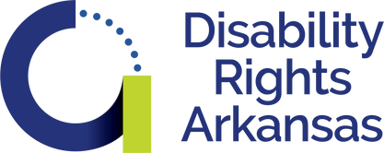

T h i s p u b l i c a t i o n w a s s u p p o r t e d b y t h e
A d m i n i s t r a t i o n f o r C o m m u n i t y L i v i n g ( A C L ) , U . S . D e p a r t m e n t o f H e a l t h a n d H u m a n
S e r v i c e s ( H H S ) a s p a r t o f a f i n a n c i a l
a s s i s t a n c e a w a r d w i t h 1 0 0 p e r c e n t f u n d i n g
b y A C L / H H S . T h e c o n t e n t s a r e t h o s e o f t h e a u t h o r ( s ) a n d d o n o t n e c e s s a r i l y
r e p r e s e n t t h e o f f i c i a l v i e w s o f , n o r a n e n d o r s e m e n t , b y A C L / H H S , o r t h e U . S . G o v e r n m e n t .

Information, referrals, and advice
How can DRA
help?
Individual and family advocacy
Legal representation
Self-advocacy training

Scan the QR Code Learn More About our TBI
Advocacy Efforts

Contact us
Phone: 501-296-1775 V/TTY
Toll Free: 800-482-1774 V/TTY
Email: info@disabilityrightsar.org

