How can you get involved in advocacy?
Ensure that people with disabilities have fair access to their community and shape their lives the way they want.

Provide specialized in-
How can DRA
help?
person or virtual training for advocacy groups.
Provide technical
assistance for individuals and people wanting to
start an advocacy group.
Scan the QR Code to Schedule a Training

Contact us
Phone: 501-291-0906
Toll Free: 800-482-1774 V/TTY
Advocacy@DisabilityRightsar.org

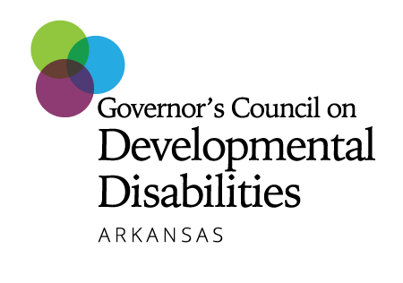
Funding for the described programs and this publication provided under Public Law 106-402 as administered by the Governor’s Council on
Developmental Disabilities for the State of Arkansas. Its contents are solely the responsibility of the authors and do not necessarily represent the official views of the GCDD.

